|  |  |  |
| --- | --- | --- |
| **Názov** | **Triviálny názov** | **Využitie** |
| AgNO3 | laspis |  |
| KMnO4 | hypermangán | dezinfekcia, ekzémy kúpele |
|  |  |  |
|  |  |  |

|  |  |
| --- | --- |
| **látka** | **percentá** |
| HCl = |  |
| HNO3 |  |
| H2SO4 |  |
| H2O2 |  |
| NH3 |  |

**Piktogramy=_______________________________________________________________________**

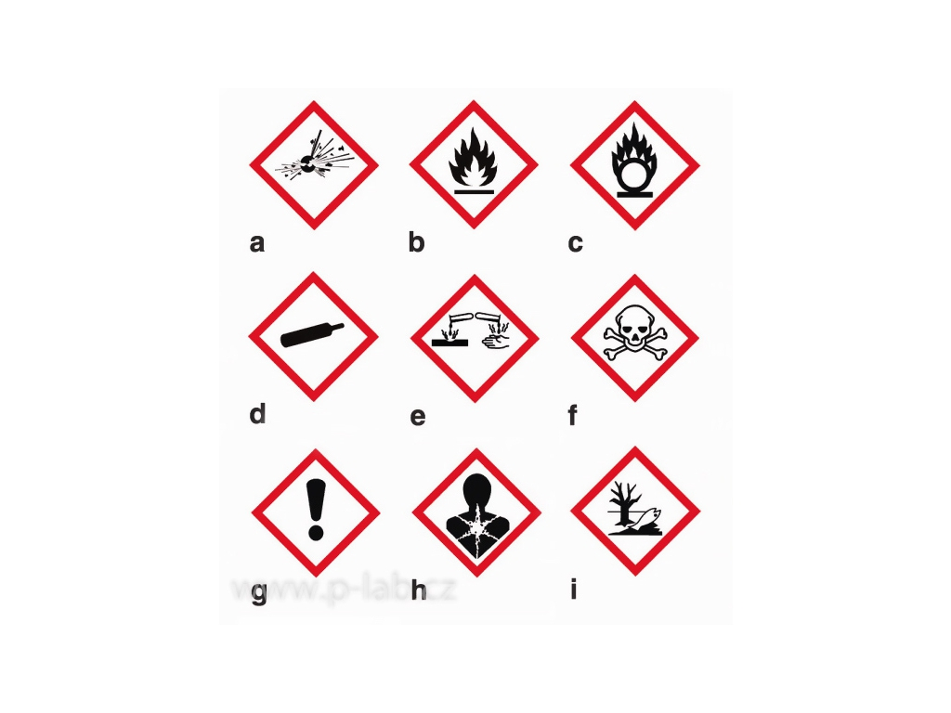 



**Jedy**

* metanol _____________, arzén___________________, ortuť_____________________, kyanidy______________________, biely fosfor
* sodík sa uchováva _____________________dôvod:__________________________________
* biely fosfor sa uchováva_________________dôvod:__________________________________
* organické látky – sú všetky___________________________________________